|  |  |  |  |  |  |
| --- | --- | --- | --- | --- | --- |
| Date | 7-Dec-22 | | | Tester Name | Mohammad Yusuf |
| Environment | Penfax - Test | | | Login used |  |
| Operating System | Windows | Version: | Update: | | |
| Software Used | Select Software | Version: | Update: | | |
| Select Software | Version: | Update: | | |
| Release version |  | | | | |
| Title |  | | | | |
| Test Type | Regression | | | | |
| Test Scenario |  | | | | |
|  |  | | | | |
| Expected Results |  | | | | |
| Pass/Fail | Select | | | JIRA# | N/A |

Describe your steps with screenshots:   
Search for MEPP Retired member

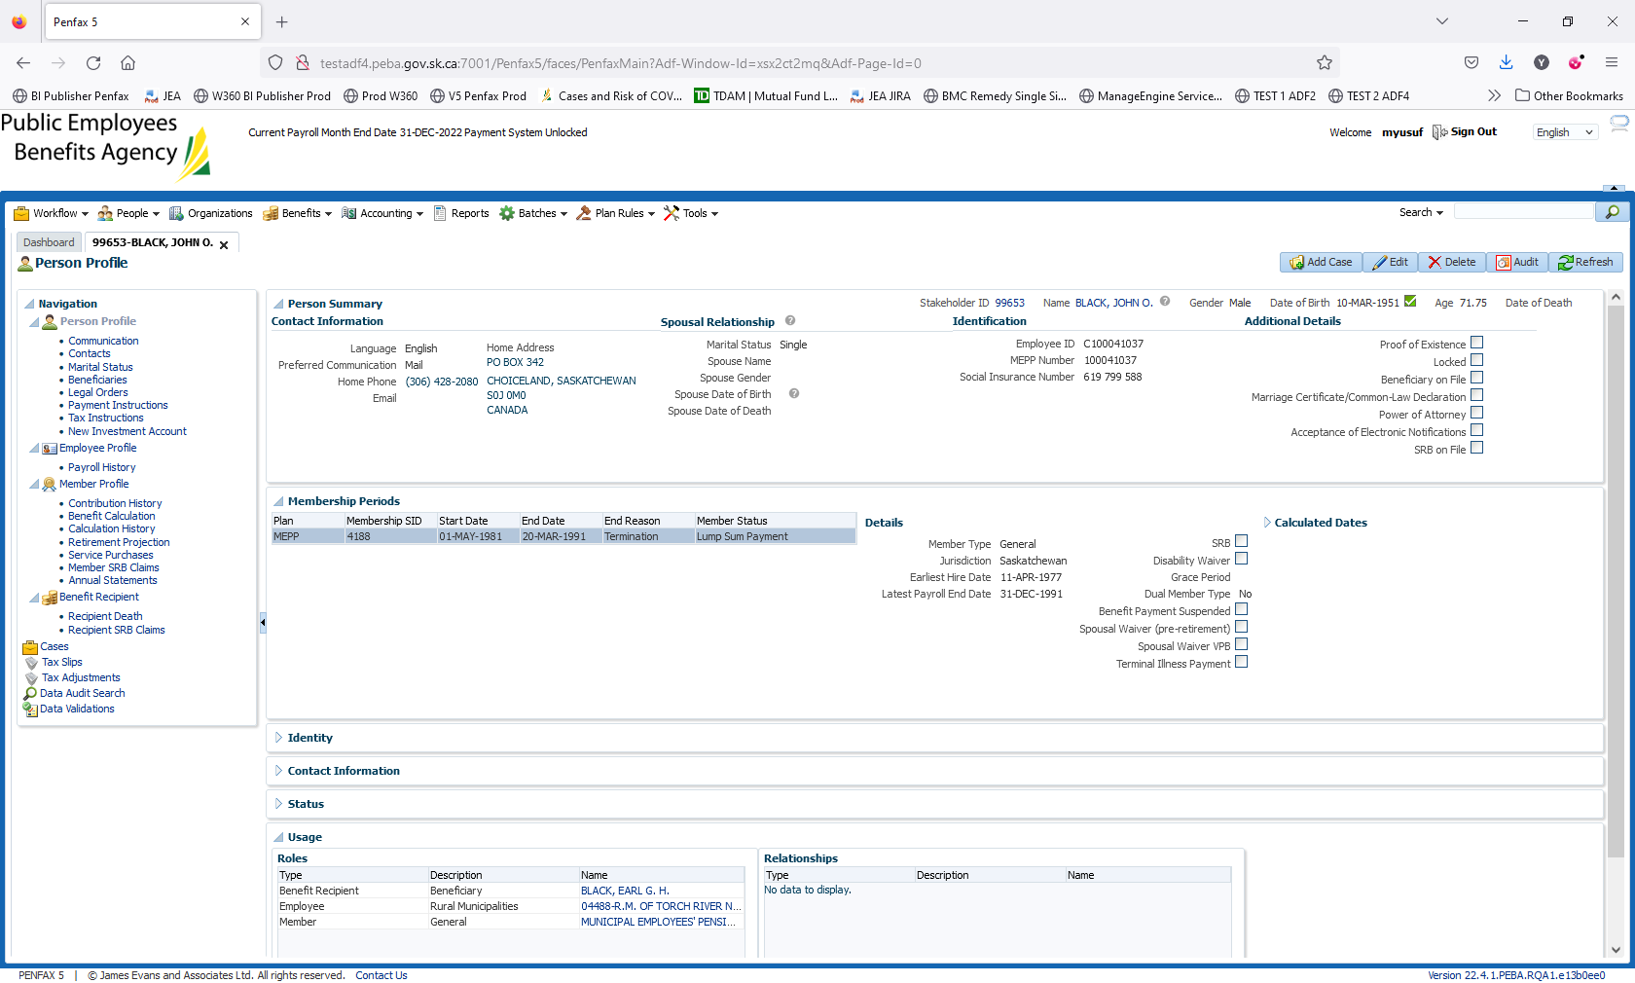

Navigate to Person Profile -> Edit. Enter Date of Death

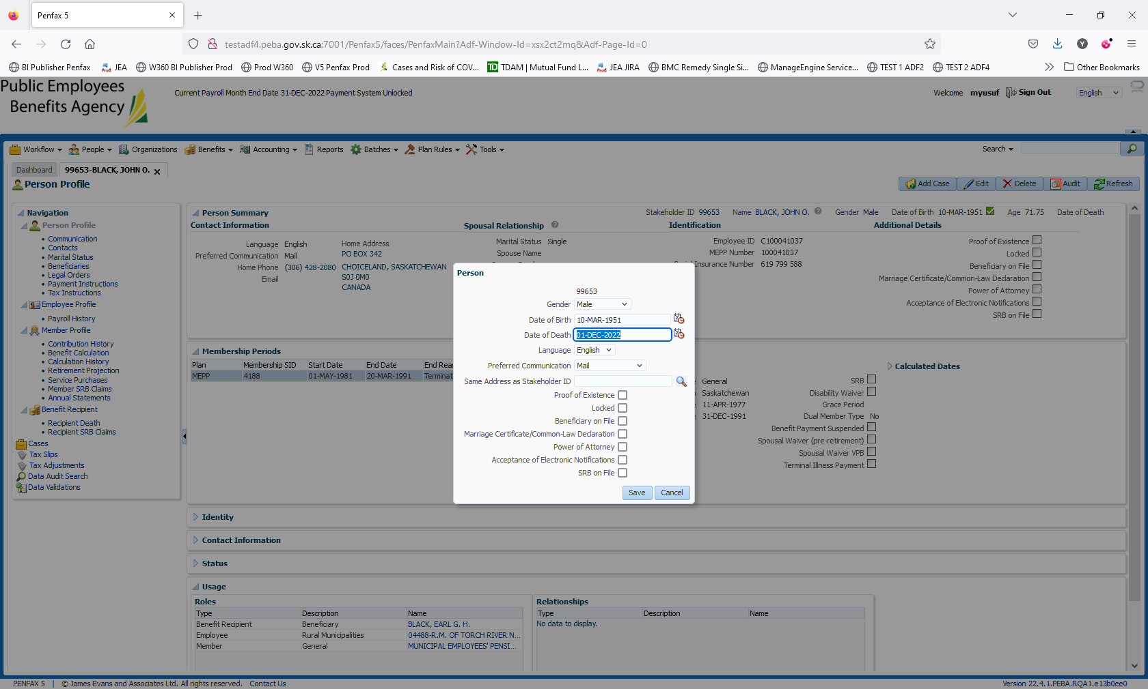

Date of Death 1 Dec 2022

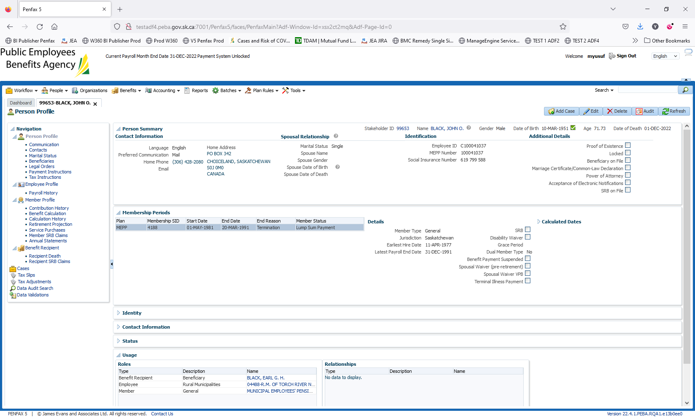

Save it

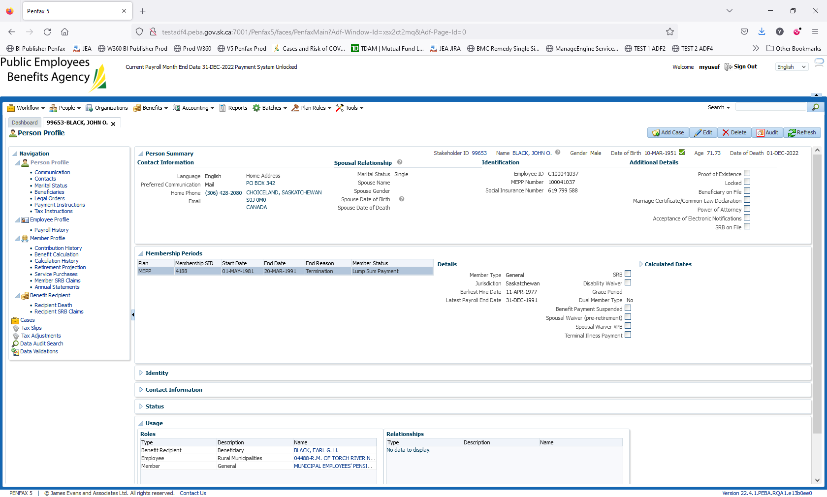

Run the Death Calculation. Benefit Recipient - > Recipient Death -> New calculation   
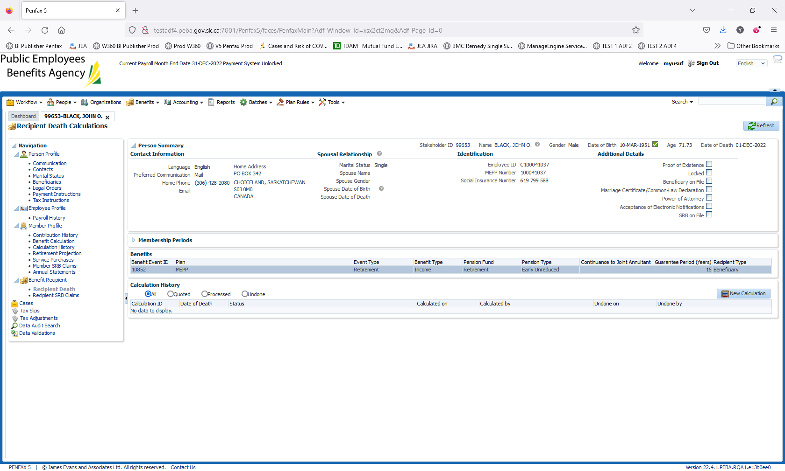

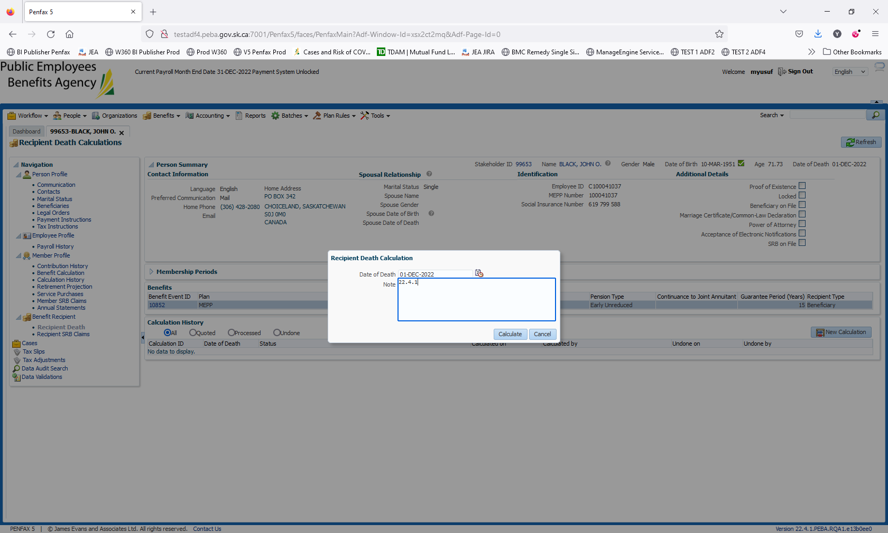

Validate if the Date is appearing correctly

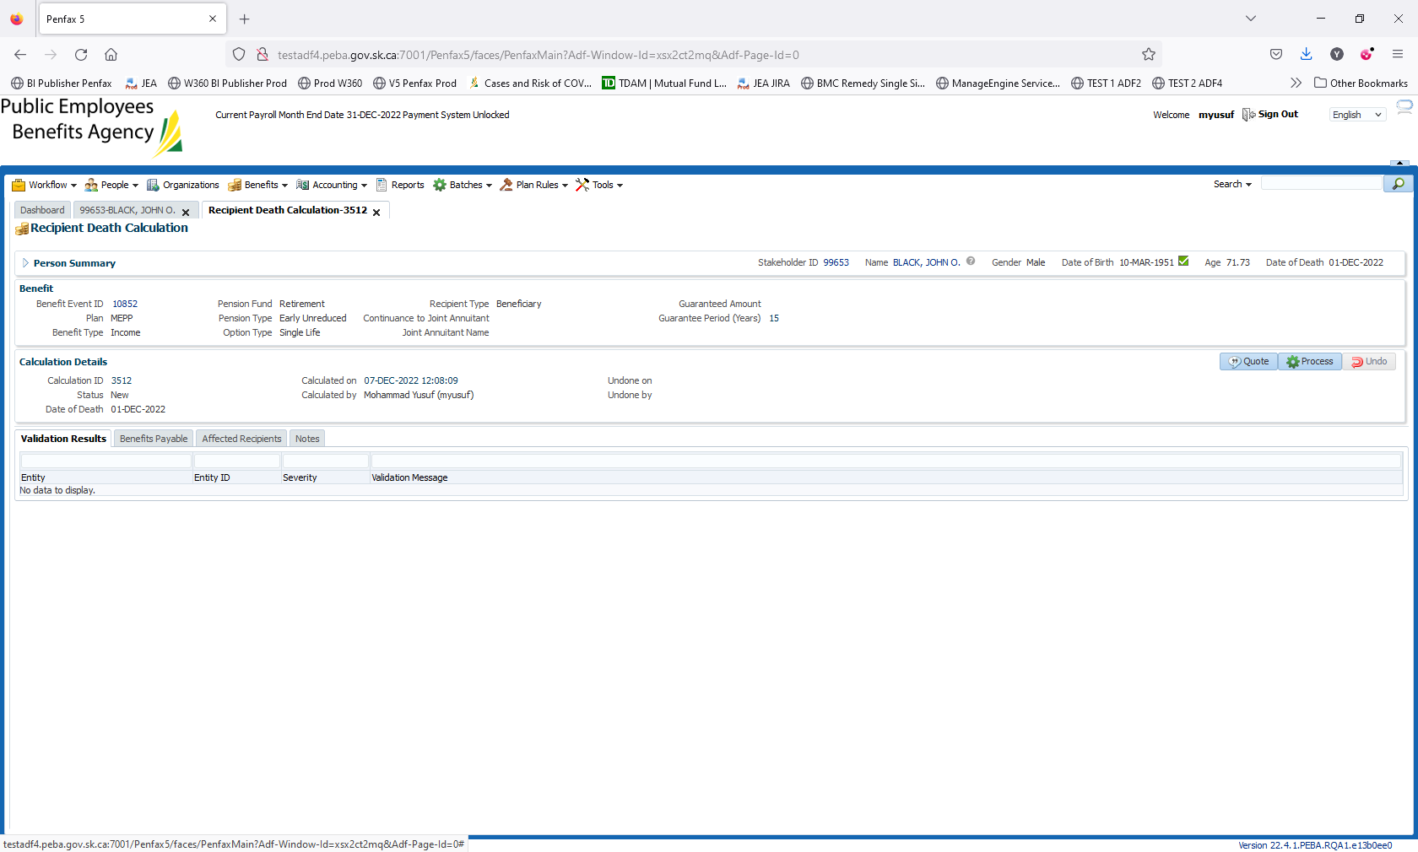

Click on Process

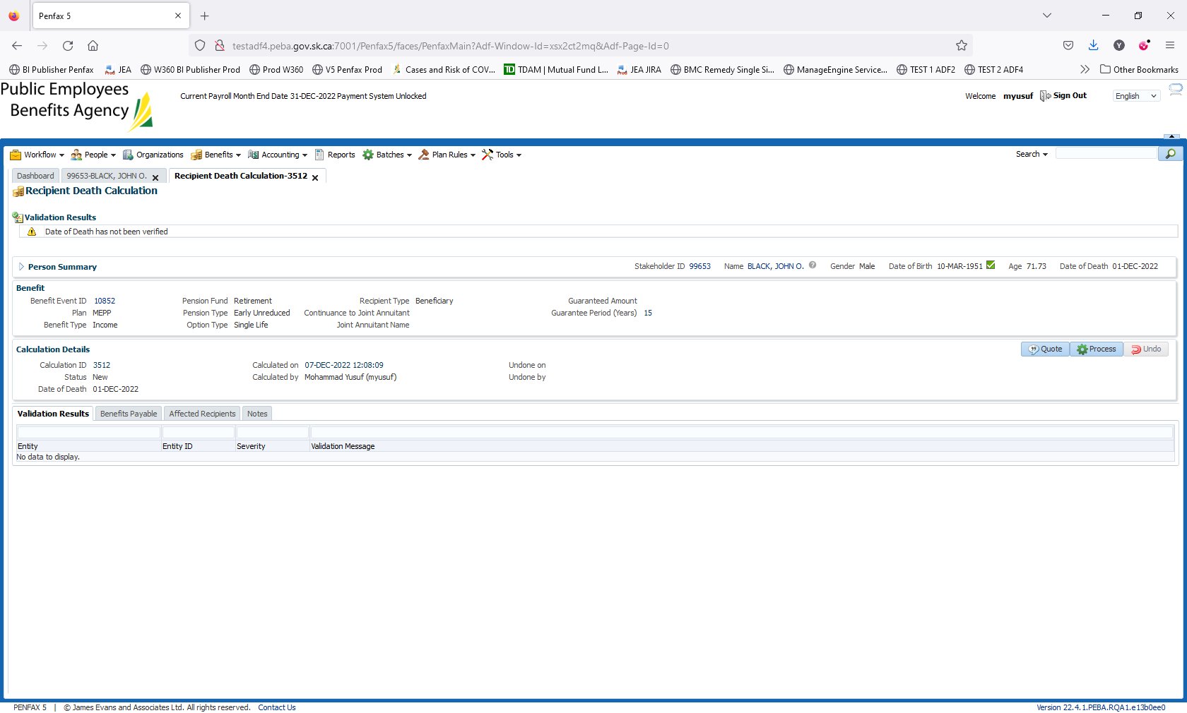

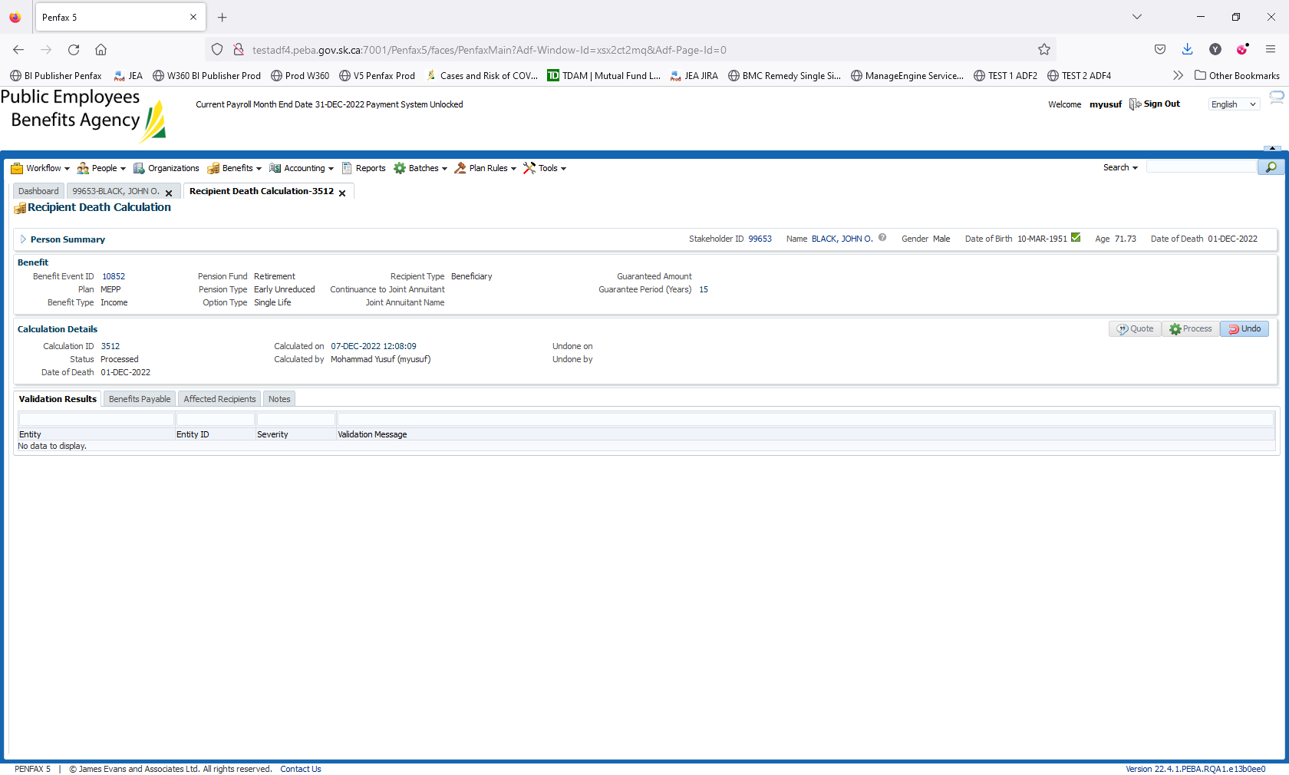

Click on Process again.

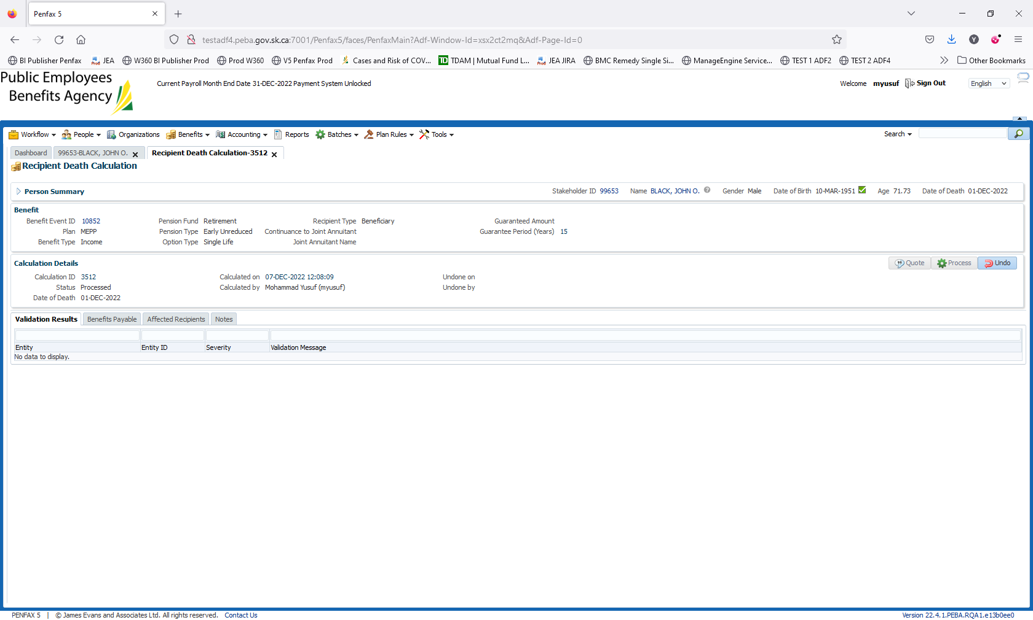

Death Calculation is processed

Navigate to Person Profile -> Beneficiaries

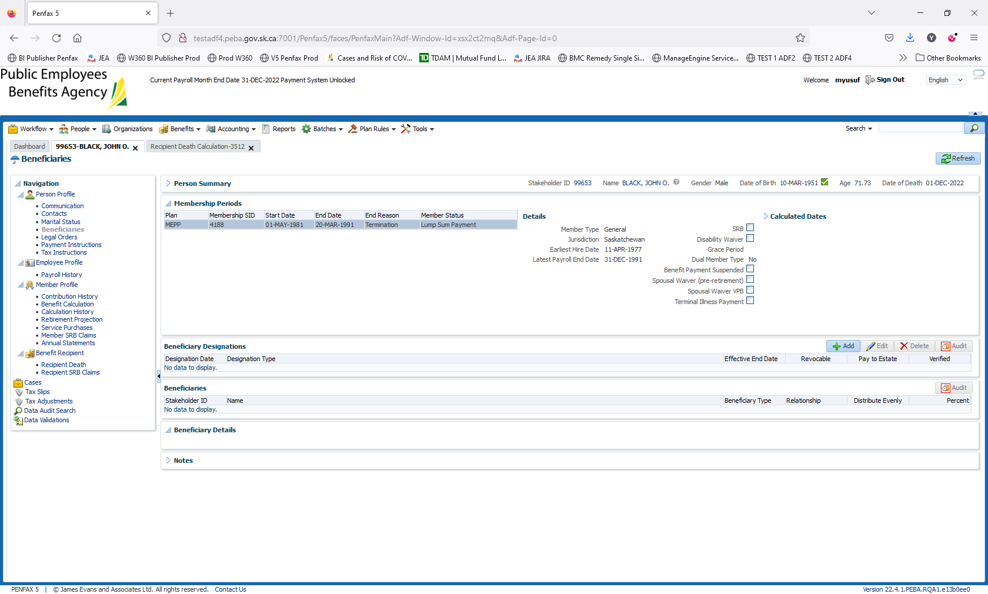

Beneficiary Designations. Click on Add

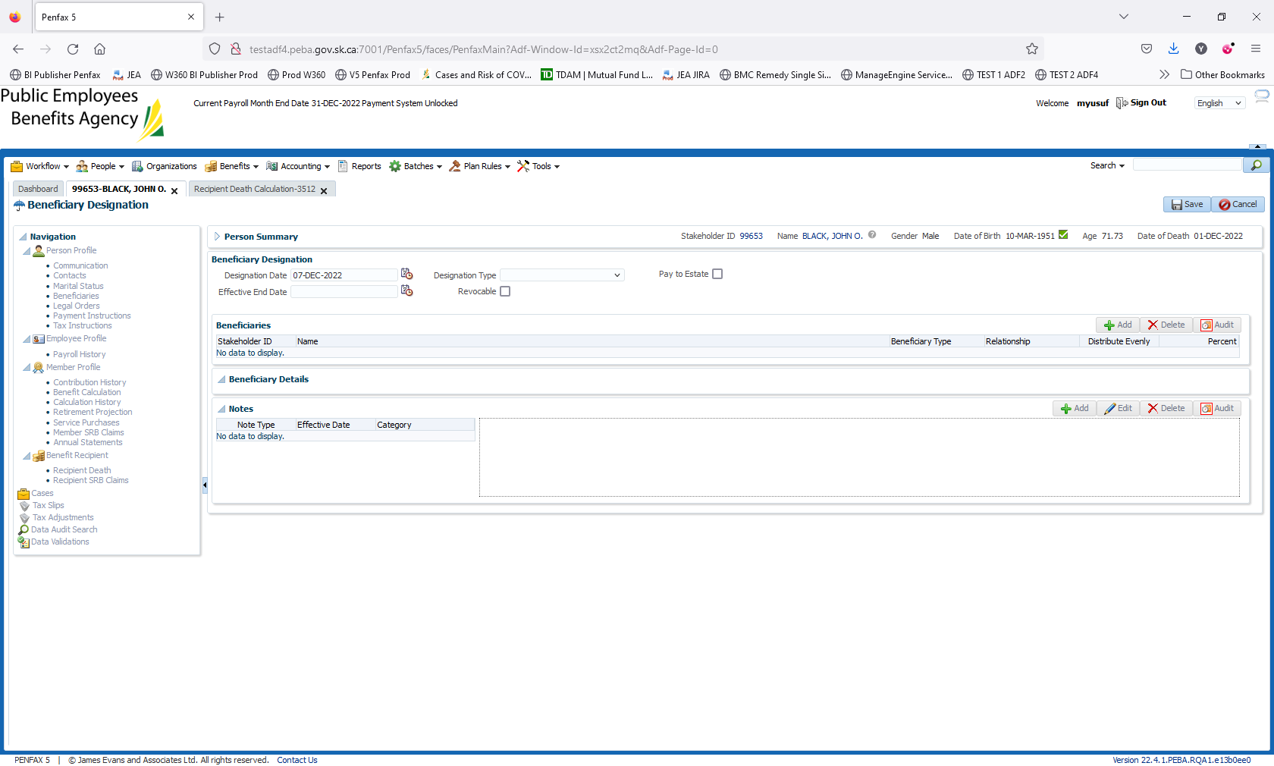

On Beneficiaries -> Click on Add

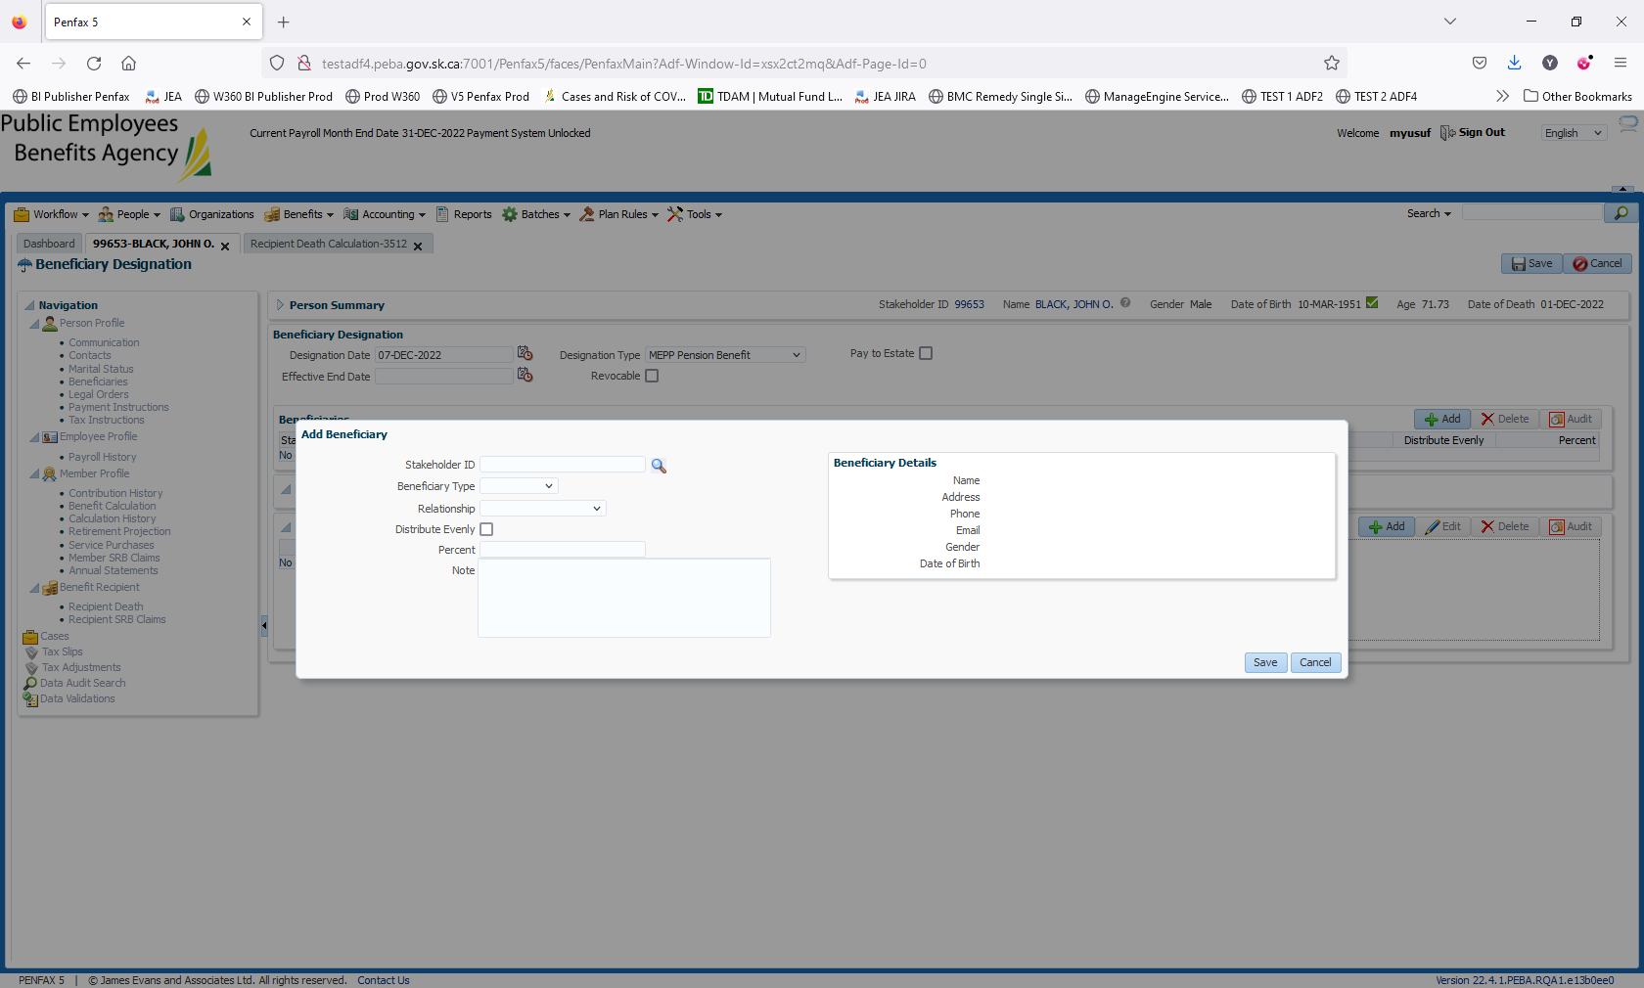

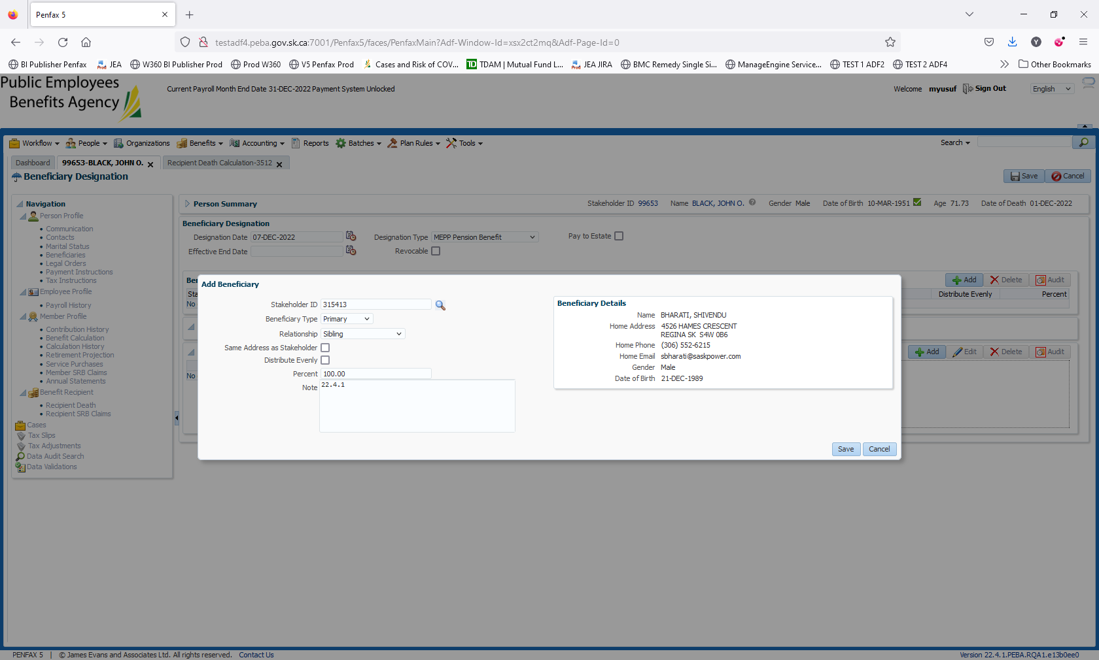

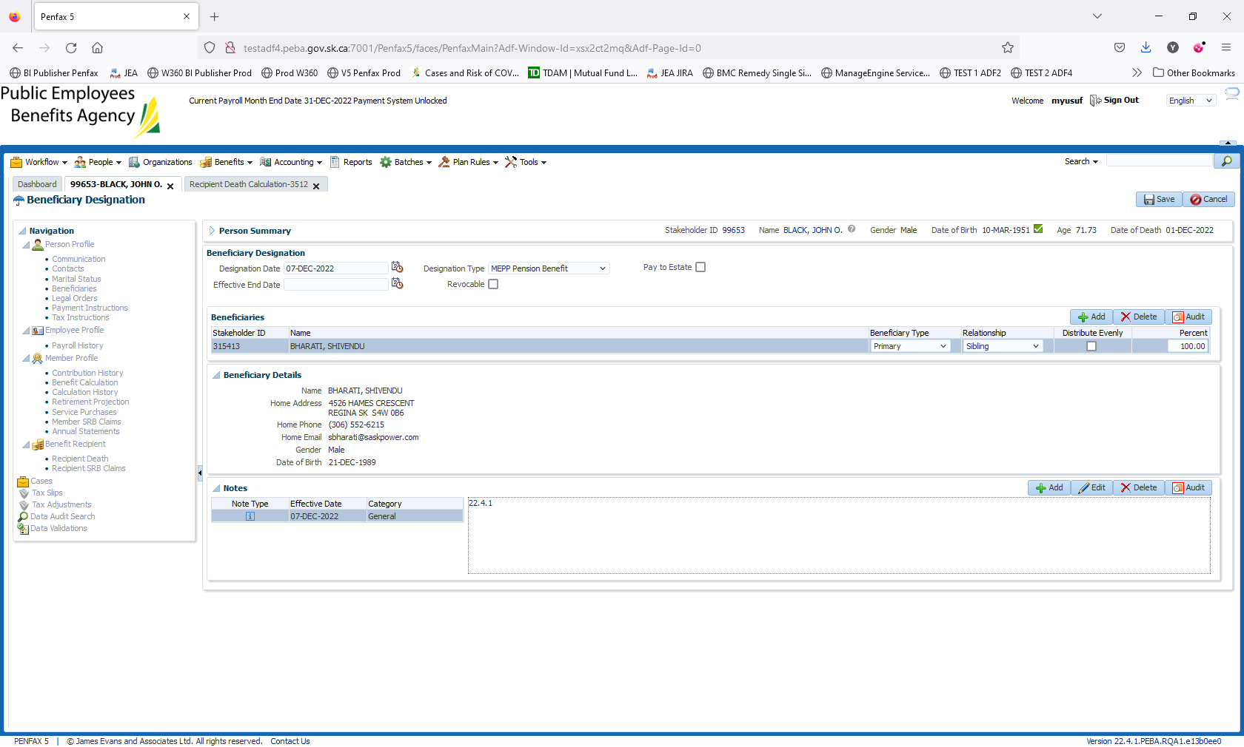

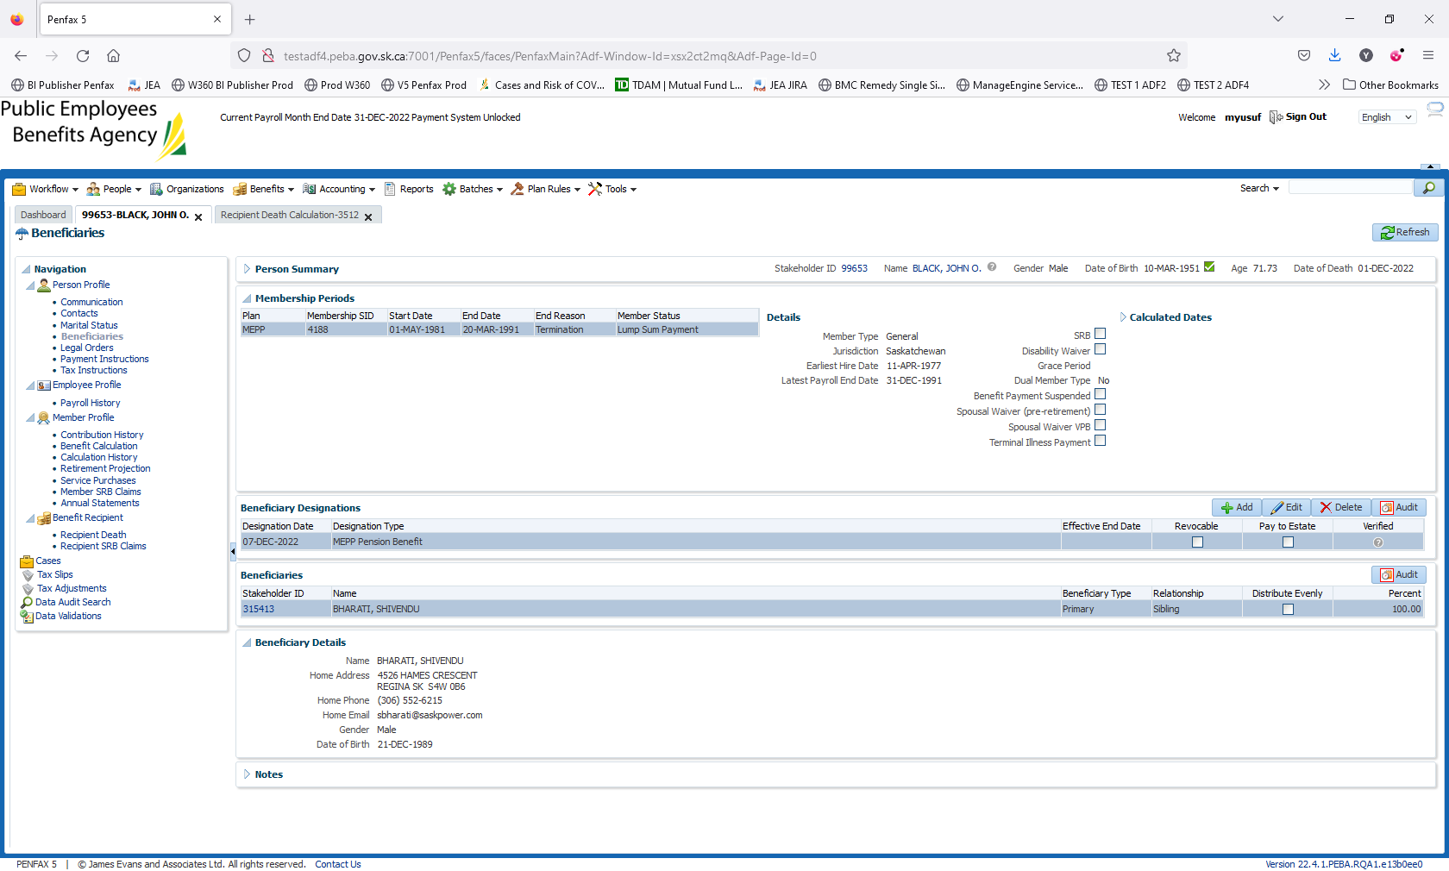

Click on Save   
Beneficiary added upon member Death.

